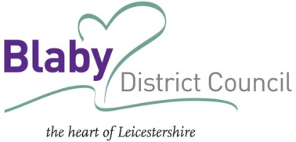

Private and Confidential
Befriending Scheme Referral

Referrer Details
Name: |  | Date:
Telephone No: |  | Email Address:

Client Details
Title | Mr/Mrs/Miss/Ms/Other
First Name
Prefer to be called
Surname
Daytime telephone No
Evening telephone No
Date of birth
Gender
Please tell us about current health conditions and any disabilities
Brief family & social history i.e. employment, interests, recent bereavement
What do you hope to get out of the befriending service?
Reduced feelings of isolation
Reduced feelings of anxiety
Improved levels of wellbeing
Improved quality of life
Companionship
Is there anything else we should know?

I agree to my details being shared with the Telephone Befriending Scheme Co-ordinator and volunteers and confirm I have received of a copy of the scheme agreement.

Signed/signed on behalf of........................................................................................

Please send to vcshub@blaby.gov.uk
Please return to vcs.hub@blaby.gov.uk
If you have any queries/require further information please call me direct on 0116 272 7718

