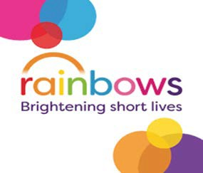
BRAUNSTONE TOWN COUNCIL

TOWN MAYOR’S CHARITY FUNDRAISING EVENT

10,000 steps challenge - Get active this year and take 10,000 steps a day for 30 days. Use your smart phone or watch to keep an eye on your progress. Ask your mates to sponsor you.

Choose when you would like to start but the 30 days will need to be completed between February & April 2023.

SPONSOR NAME | AMOUNT | RECEIVED

